**DATA SCIENCE PROJECT**

Name: - Vishvam Salwan

Roll No: - 102003646

Subgroup: - Coe19

R QUERIES: -

**1.Importing library**

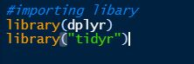

**2.Reading Files**

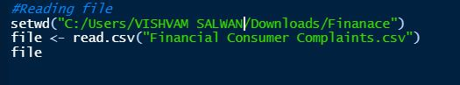

**3.Checking N.A Value**

**C:\Users\PC\Desktop\semester 5\data science Fundamental\project\screenshot\3.JPG**

**4.Replacing N.A Values**

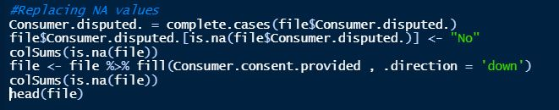

**5.Removing Tags(Unwanted) Columns**

**C:\Users\PC\Desktop\semester 5\data science Fundamental\project\screenshot\5.JPG**

**6.Filling Empty Column**

**C:\Users\PC\Desktop\semester 5\data science Fundamental\project\screenshot\6..JPG**

**7.Droping Rows With No Dates**



**8.Filling Empty Columns**

**C:\Users\PC\Desktop\semester 5\data science Fundamental\project\screenshot\8..JPG**

**9.Label Encoding**

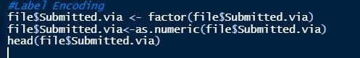

**10.Final Csv File**

**C:\Users\PC\Desktop\semester 5\data science Fundamental\project\screenshot\10..JPG**

**DATASET: -**

1.Dataset Before Preprocessing: -

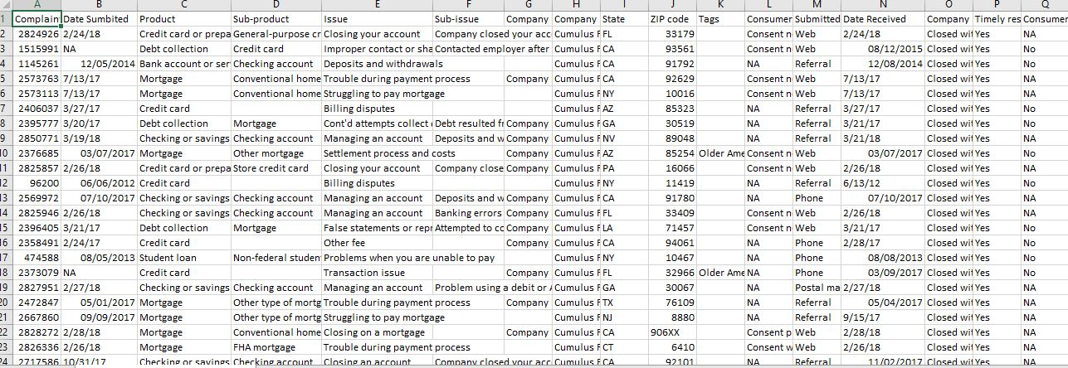

2. Dataset After Preprocessing: -

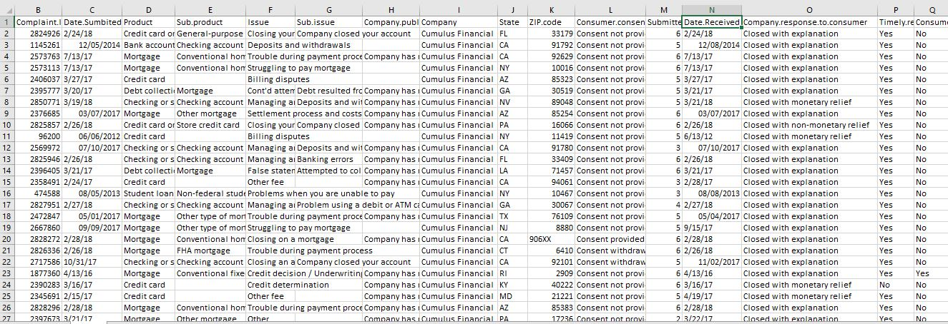

TABLEAU: -

**1.Total Complaints: -**

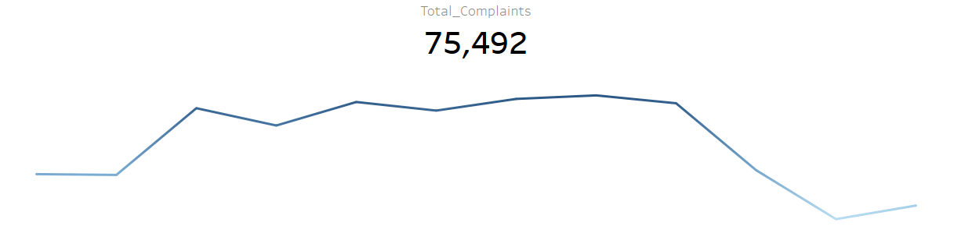

**2.Time Response: -**

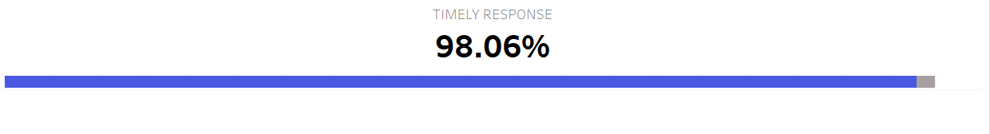

**3. In Progress: -**



**4.Resolved at No Cost: -**

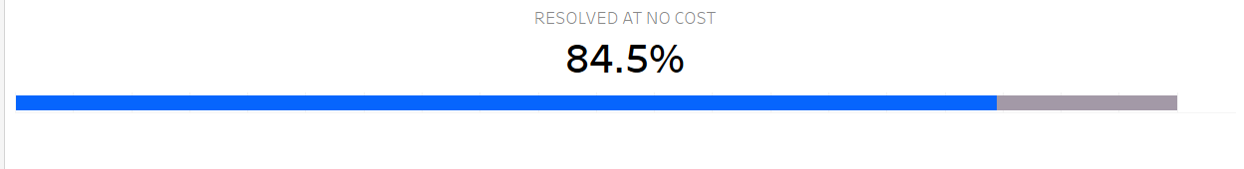

**5.Issues: -**

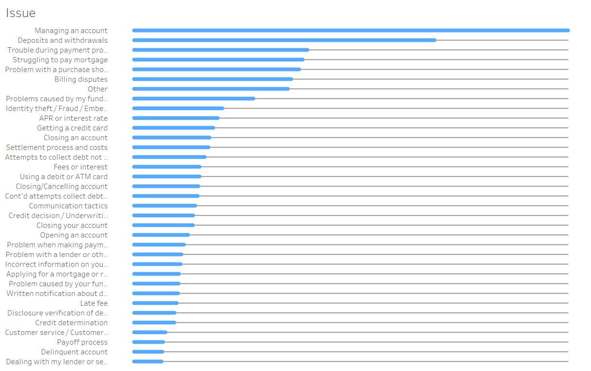

**6.Complaint by States: -**

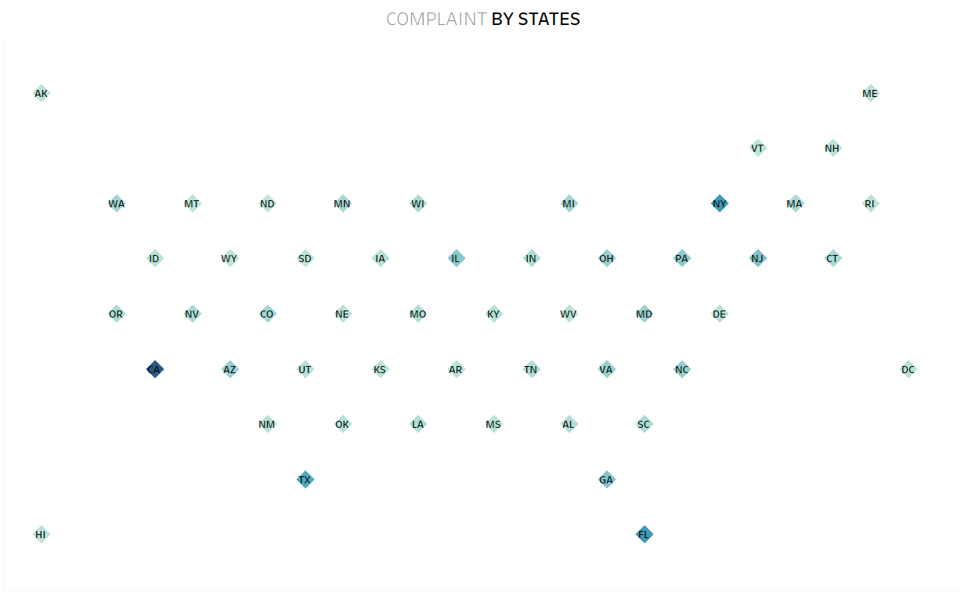

**7.Consent Provided: -**

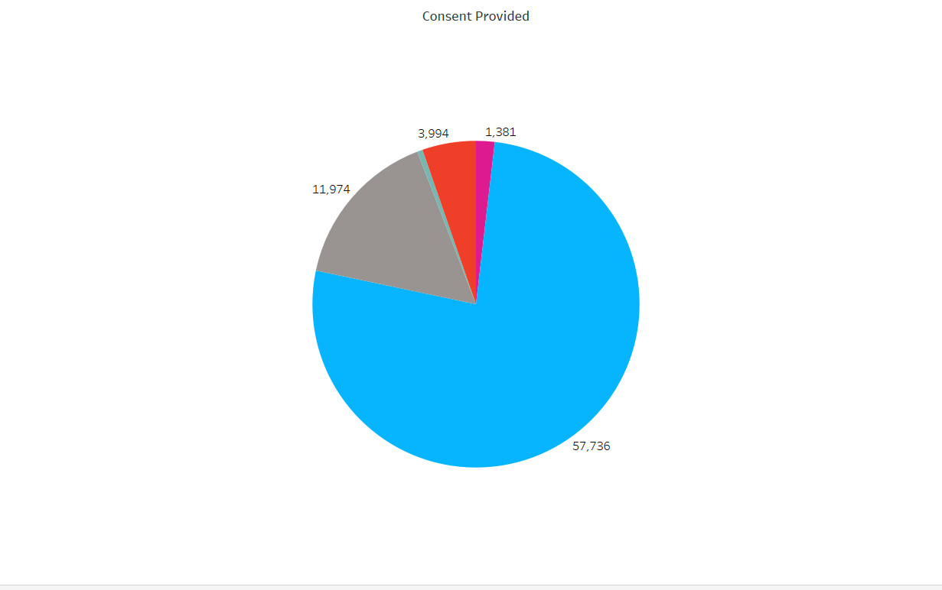

**8.Complaint by Product: -**

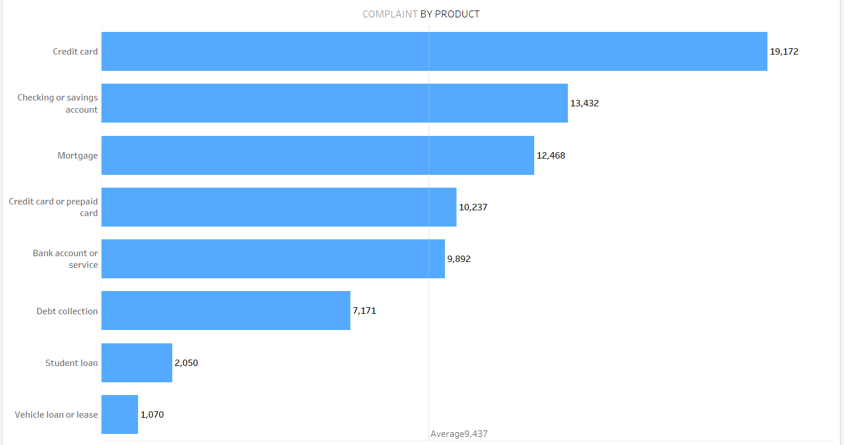

**9.% Customer Disputed: -**

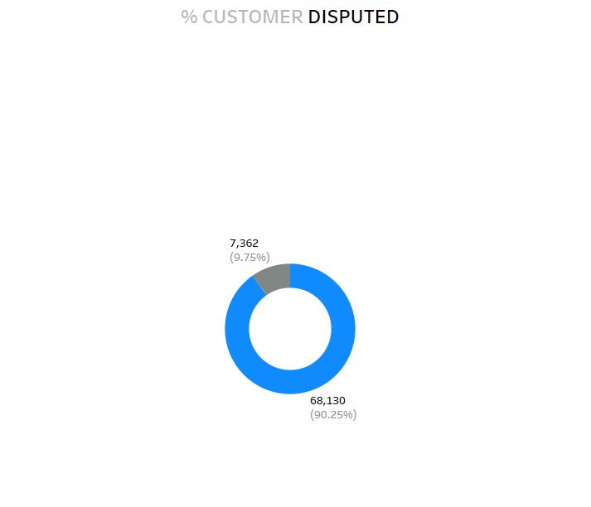

DASHBOARD: -

